Exercise 1 and 2

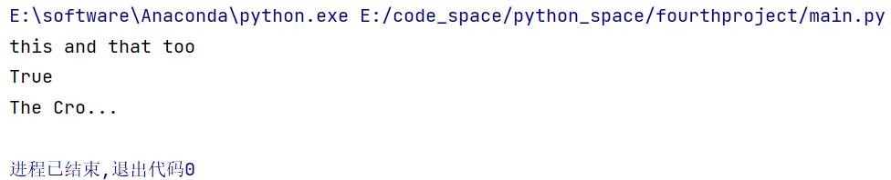

Exercise 3 and 4

